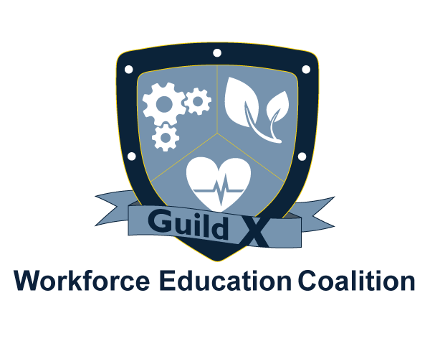

Agenda
Manufacturing Guild X

Sept. 12, 2018

I. Welcome Marybeth Jacobsen

II. Introductions (5 min.)

III. Business Spotlight – Savage Machining (10 min.) Sheralee Connors
Operations Mgr., Savage Machining

III. Goal: Advisory Boards

Ventura College Mfg. Technology Curriculum John Clark
Report on summer curriculum update (10 min.) Lead Instructor, Ventura College

Career Education Committee
Advisory Board Working Group Report Bill Pratt
(10 min) Dr. Alexandria Wright, VCCCD
Director Econ. & Workforce Dev.
IV. Goal: Expanding the Worker Pipeline

Uniquely Abled Project – Training high functioning Mike Bastine
autistic workers for manufacturing sector jobs Deputy Sector Navigator,
(20 min.) Advanced Manufacturing

New manufacturing/mechatronics training space Darrell Gooden
(10 min.) VCOE Industry Liaison
Dr. Alexandria Wright, VCCCD
Director Econ. & Workforce Dev.
V. Announcements
www.WorkforceEC.org • 805-218-2127 • info@WorkforceEC.

Next meeting: Oct. 10, 8:00 – 9:30 a.m., Pharos Center/VCCF 4001 Mission Oaks Blvd, Camarillo

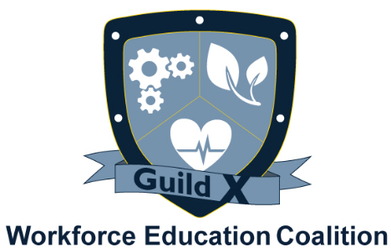

Minutes
Manufacturing Guild X: ADVISORY BOARDS
June 6, 2018
4001 Mission Oaks Blvd., Camarillo, CA

Present: Michael Bastine, John Clark, Felicia Duenas, Gavriela Guerrero, Marybeth Jacobsen, Brittany Manzer, Chris McHugh, Dr. Tiffany Morse, Patrick Newburn, Bill Pratt, Jason Robinson, Mairelise Robinson, Israel Rodriguez, Ernan Ruiz, Tim Schmidt, Bryan Went, Erick Went, and Peter Zierhut

- Meeting was called to order by Marybeth Jacobsen at 8:11 A.M.

- Business Spotlight

Jacobsen invited Guild members to sign up to be Business Spotlights in upcoming meetings. The Business Spotlight is open to all industry professionals to present a brief overview of what their business does for the first 5-10 minutes of every Guild meeting. Spotlights will be recorded and available to share on the WEC website.

- Meeting Review

Jacobsen updated Guild members about the WEC’s Coalition Letter to support AB 1743. The letter raised awareness among local elected officials about the importance of CTE funding and the impact that altered funding structures would have on CTE. Currently, there is no way to know if the Governor’s plan or AB 1743 will be implemented. The bill is in committee and an outcome should be known soon.

John Clark continued his presentation from previous meetings to review the machinist curriculum available at Ventura College. The Guild completed a review of the CNC Operator Certificate and began reviewing the stackable CNC Machinist Certificates. Clark walked Guild members through each course available and with the help of Jason Robinson thoroughly recorded Guild input. He assured industry members that proposed curriculum updates would be completed this summer for target implementation in fall 2019.

Guild members were invited to continue this kind of review with Clark on all other manufacturing related courses.

- Announcements

- Manufacturing Guild X Chair
  - The Guild needs a new Manufacturing Guild Chair. Responsibilities include: Moderating Manufacturing Guild X meetings and occasional input to assist in creation of the meeting agendas.
  - If you are interested or would like to nominate someone, please email Marybeth Jacobsen at M.Jacobsen@WorkforceEC.org

- All Guild materials, agendas, minutes, and WEC events can be found on the WEC website. An event calendar can be reached from the home page. Guild agendas will be posted on the calendar.
  - WEC Calendar: https://www.workforceec.org/calendar-1/
  - WEC Guild X: https://www.workforceec.org/guild-x

- Manufacturing Operators Hiring Event
  - Tuesday, June 19th from 3pm – 6pm the WDB will be hosting a hiring event for entry-level jobs in manufacturing operations. Guild members are invited to attend and seek candidates for vacant positions. See attached flyer.
  - Venue: America’s Job Center of California-Oxnard; 2901 N. Ventura Rd., 3rd floor, Oxnard

- Veterans Job Fair
  - On August 25th at 10 am there will be a job fair for veterans at the Pharos Center for Innovation, 4001 Mission Oaks Blvd, Camarillo. Guild members are invited to attend and interview veterans for vacant positions. Flyer to follow.

- Action Steps

Programs in Design:
- VCCCD Career Education Committee – Guild sets agenda item for bi-monthly committee meeting

- Next Meeting: September -- 2018, 8:00 a.m. at Pharos Center for Innovation
** Guild will be dark in July and August for summer recess**

Meeting was adjourned at 9:33 A.M

Recorded by:
Mairelise Robinson
Director of Operations

